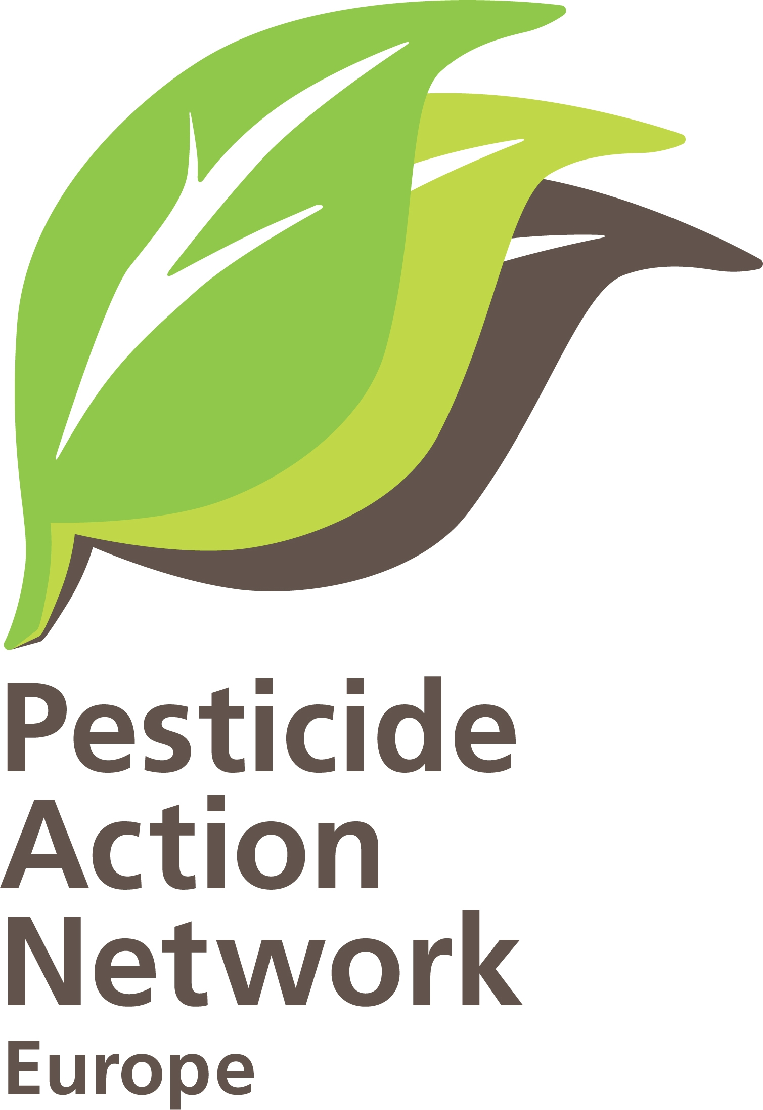 | Ban on the use of 1,3 Dichloropropene needed  Brussels, 16-09-2010, PAN-Europe  Hans Muilerman.

Concerning: Vote in EU-Council on 1,3 Dichloropropene.

Dear Member of the Standing Committee,
Dear National Representative for the EU.

PAN-Europe is calling upon you to support a total ban on the use of the pesticide 1,3 Dichloropropene. Soon a discussion will take place in EU Council to take a decision on the approval of this substance. 1,3 Dichloropropene is a probable carcinogen and dangerous for people in fumigation areas. Additionally the use would be in complete contradiction with EU policy (Council Regulation 73/2009 on Good Agricultural and environmental condition; Directive 2009/128 on the sustainable use of pesticides). Alternatives are readily available. We hope you will support the original SANCO-proposal for non-inclusion and not allow any essential use or other loophole constructions.
Below you will find our main arguments to ban the use of 1,3 Dichloropropene forever.

1,3 Dichloropropene is dangerous.
Animal testing shows 1,3 D is mutagenic, it can cause chromosome aberrations, cause DNA fragmentation and several tumours (liver, urinary bladder, lung) in different test animals. EFSA (Opinion 2006) concluded on the basis of the weight of the evidence 1,3 D to be an in vivo genotoxic substance. PAN-Europe thinks this classification should automatically lead to a ban on 1,3 D because citizens shouldn’t be exposed to carcinogens while no-effect-doses are unlikely to exist for these substances. EFSA however decided an acceptable dose can be set (0,30 mg/M3) for exposure through the air and ‘expects’ 1,3 D to degrade in the atmosphere. This ‘acceptable dose’ is at or below the level calculated and analysed along treated fields (H.Buurveld et al. University Groningen, IVEM SSV 39, 1988). So people living in the vicinity of treated areas are at risk, even if we accept EFSA’s acceptable risk level.

1,3 Dichloropropene helps maintaining unsustainable practices
1,3 Dichloropropene is used as a fumigant for sterilising soils. The reason for sterilising is an unbalanced soil population caused by narrow crop growing schemes and monocultures. Sterilising soils is the ultimo of unsustainability, killing soil biodiversity and destroying natural cycles and equilibriums. In stead of making use of natural elements, natural elements are disabled.
Good agricultural practices on the contrary make use of balanced soil populations for keeping pest in control, use the carbon cycle and organisms for buffering water and nutrients for plants and use the nutrient cycle to feed plants. The use of fumigants is also a big contradiction with the Framework Directive on the sustainable use of pesticides which takes Integrated Pest management (IPM) as the standard for European crop growing and crop protection (Annex III) and with Regulation 73/2009 on Good Agricultural and environmental conditions (Art. 6 & Annex III). The use of 1,3 D would make this policy a joke and block the change to sustainable practices.

Use of 1,3 D in agriculture means wiping out soil biodiversity. In nature -as a rule- after sterilisation, pioneers will occupy the soil. And because any balance between organisms is missing, a few organism will flower in the barren soil and in the next season be the secondary pest. This is a well-known effect in soil fumigation, triggering more use of pesticides.

Use of 1,3 Dichloropropene can be prevented by sustainable practices.
Alternatives for the use of 1,3 D are readily available. A wider crop rotation of course is the most logic solution and should be made mandatory. Use of nematode-resistant crop varieties are additionally a good option to prevent unbalanced situations. Any practice helping a fertile soil (moderate dunging, conservation tillage, cover crops) will also help in going towards good soil management.
On the moment several EU member states allow 1,3 D on the basis of an emergency provision in Directive 91/414 (Art. 8.4), notably Spain, Italy, Greece, the “unforeseeable danger” clause. PAN-Europe feels this is done unjustified because allowing monocultures will trigger unbalanced soils and so can’t be unforeseeable.

Use of 1,3 Dichloropropene is dumping chemical waste
1,3 dichloropropene is not synthesized as a pesticide but is a waste product in the synthesis of epoxy resins (side-product of epichlorhydrin). So one could say the use of 1,3 D is dumping chemical waste in the environment. This is the more true since half of the 1,3 D is not effective. 1,3 D consists of the ‘cis’ isomer and the ‘trans’ isomer, the latter being inactive against nematodes. A few years ago Dutch Shell even offered the ‘cis’ isomer (purified) on the market but now again an application (by DOW/Kanesho) for the complete mixture is done. The dumping of all these chlorinated chemicals (up to 280 kg/ha) is a heavy burden for the environment.

1,3 Dichloropropene approval will be a violation of European rules.
The peer-review of EFSA (2006, 2009) makes it perfectly clear that much information in the application is missing. For the majority of the >20 impurities of 1,3 D, no toxicological information is provided. The risks of residues for consumers could not be calculated as well as the potential negative effects on many (non-target) organisms. Directive 91/414 does not allow an application to proceed if crucial information is missing.

